**EXPERIMENT-2&3:**

2)Explore Git and GitHub commands

Practice source code management on GitHub.Experiment with source code in exercise 1

* Create/Login into your GitHub account

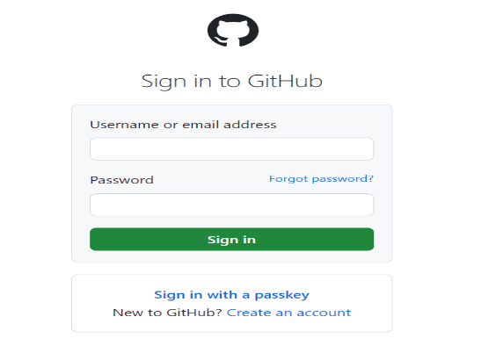

* 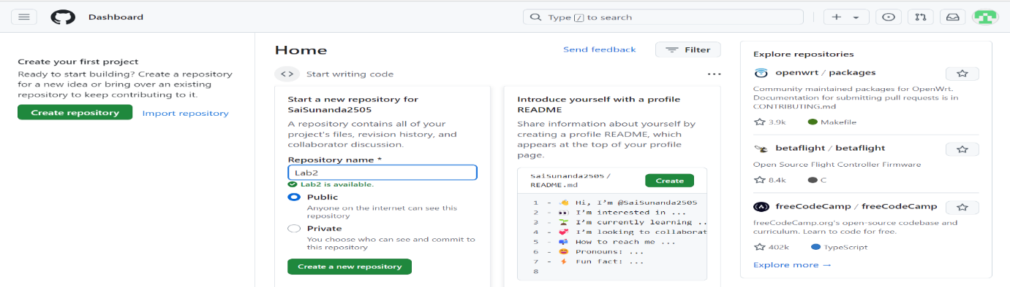Create a public repository
* 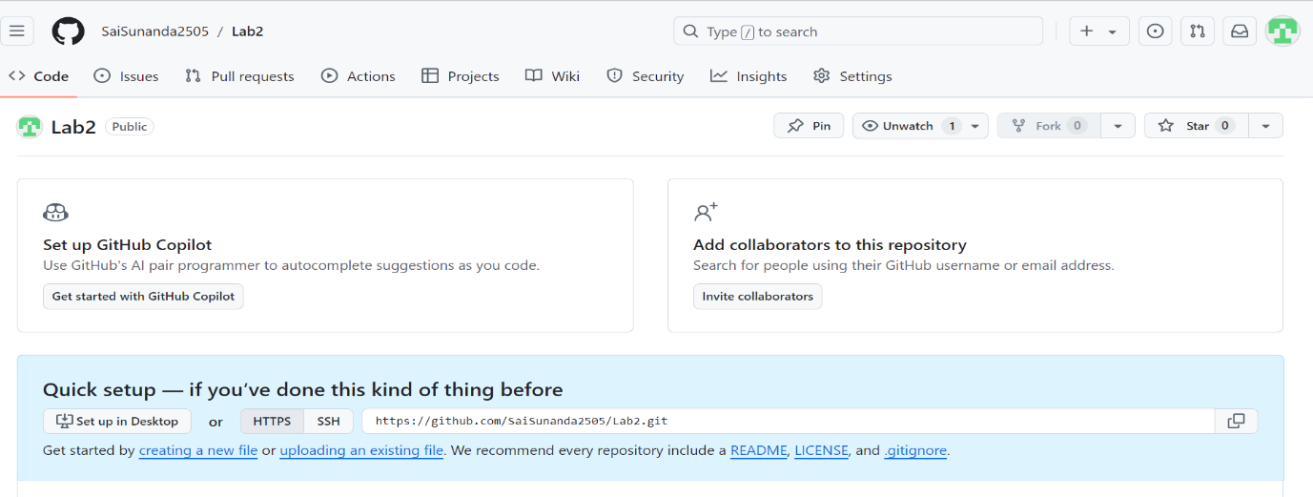Navigate to your repository and copy the HTTPS link for cloning the remote repository to local repository

**TOKEN GENERATION :**

* 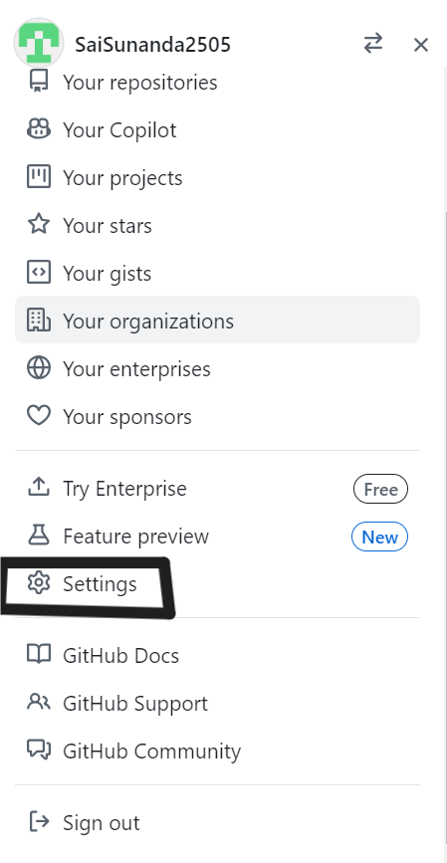Follow the given path to generate a token in GitHub

**🡪**

**🡫**

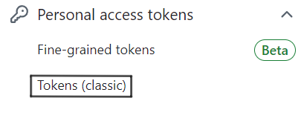

**🡫**

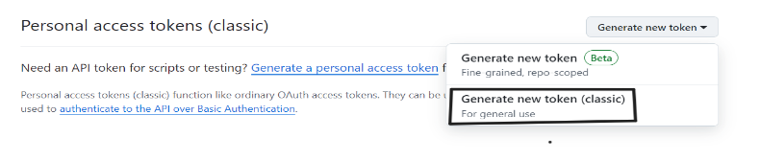

**🡫**

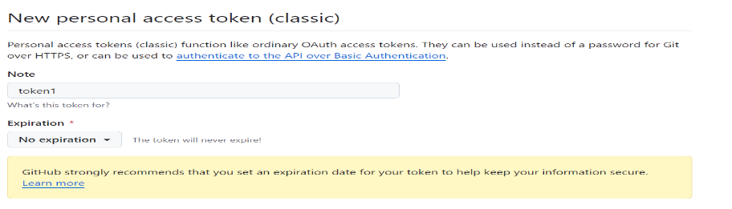

**🡫**

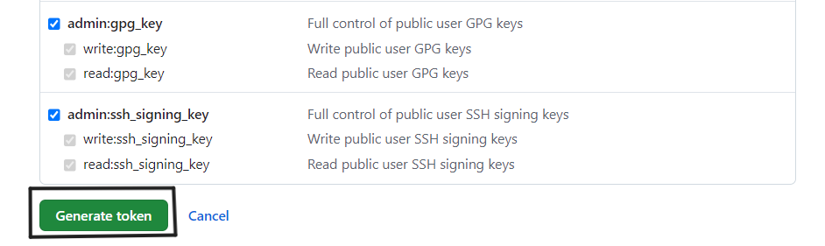

**🡫**

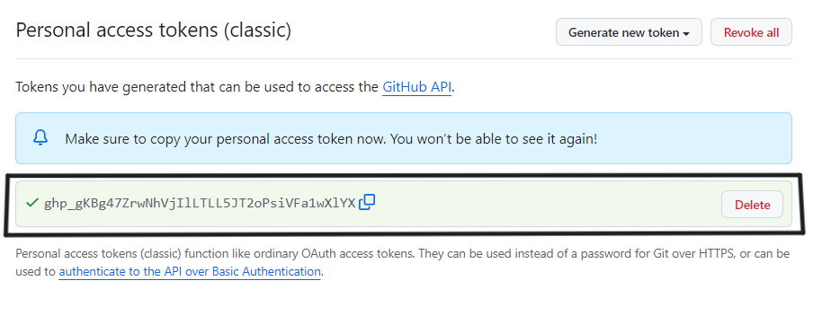

* This token is used while pushing local repository to remote repository

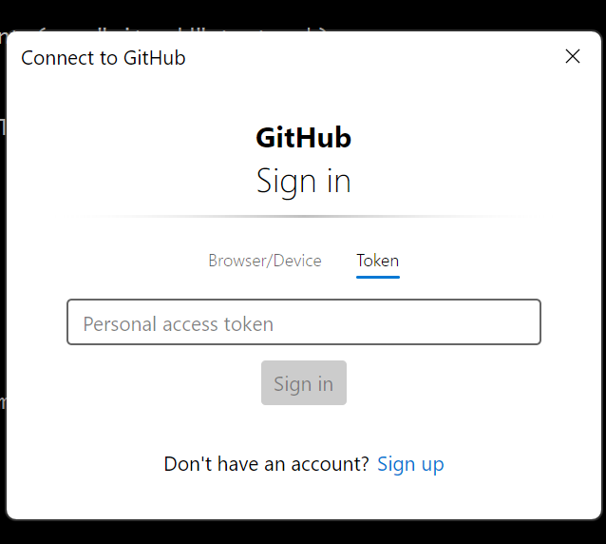

**Common Commands**

* **mkdir :**Creates a new directory(folder).
* **cd :**Changes the current directory to a specified directory.
* **ls :**Lists the contents of the current directory.
* **ls -a :**Lists all contents of the directory,including hidden files(files starting with .)
* **vi <filename> :** Open the file in vi.If the file doesn’t exist,it will be created.
* **i**  Insert text
* **Esc** Exit insert mode and return to commond mode
* **:wq** Save and quit

**Git Commands**

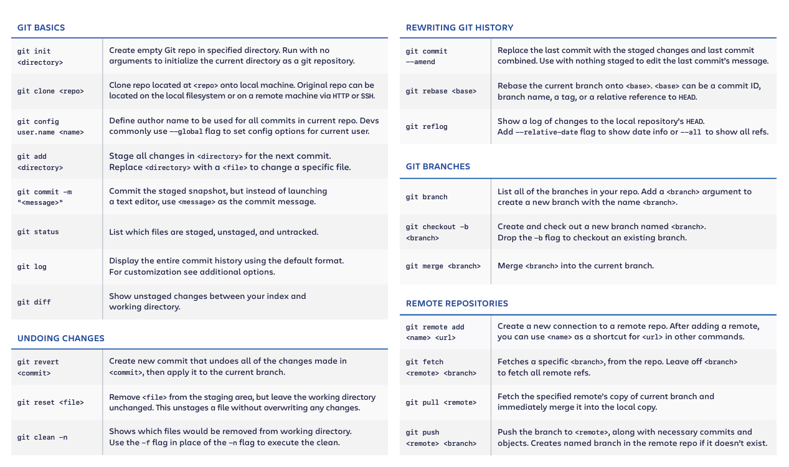

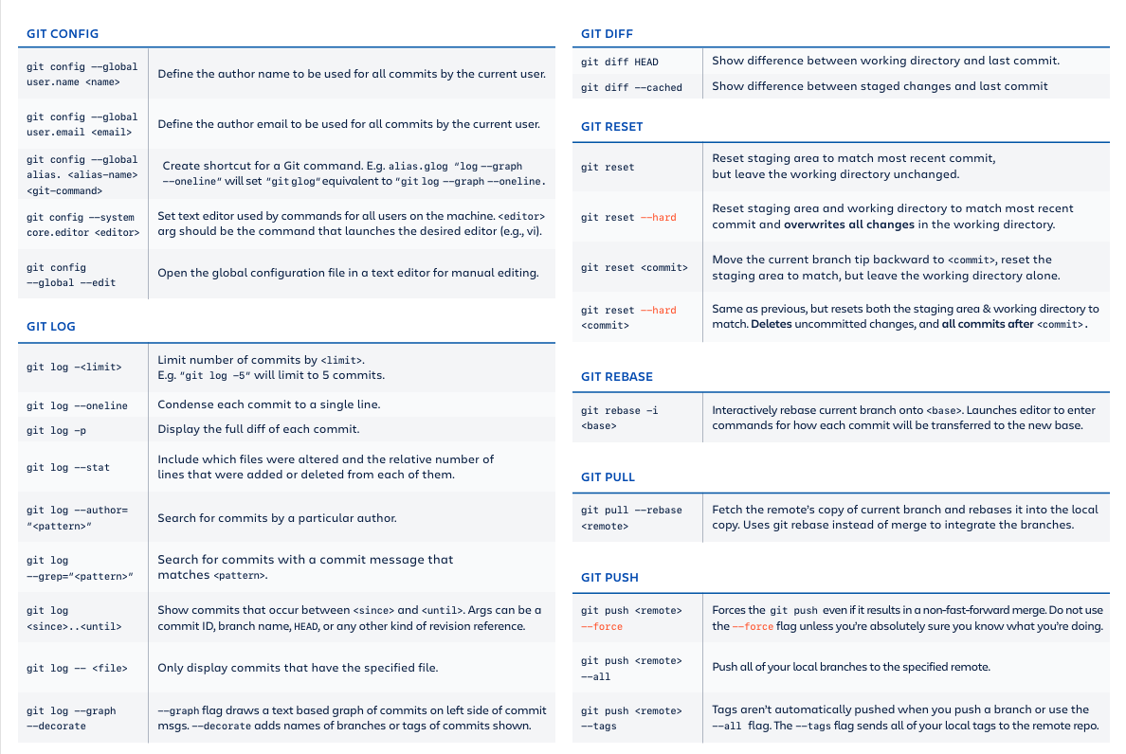

**SCENARIO 1:**

* **Creating a local repository and pushing it to the remote repository**

garid@WINTERSOLDIER MINGW64 /d/sunanda

$ mkdir myfirstproject

garid@WINTERSOLDIER MINGW64 /d/sunanda

$ cd myfirstproject/

garid@WINTERSOLDIER MINGW64 /d/sunanda/myfirstproject

$ git init

Initialized empty Git repository in D:/sunanda/myfirstproject/.git/

garid@WINTERSOLDIER MINGW64 /d/sunanda/myfirstproject (master)

$ echo "README.doc">>Readme.md

garid@WINTERSOLDIER MINGW64 /d/sunanda/myfirstproject (master)

$ ls

Readme.md

garid@WINTERSOLDIER MINGW64 /d/sunanda/myfirstproject (master)

$ touch index.html

garid@WINTERSOLDIER MINGW64 /d/sunanda/myfirstproject (master)

$ ls

Readme.md index.html

garid@WINTERSOLDIER MINGW64 /d/sunanda/myfirstproject (master)

$ git status

On branch master

No commits yet

Untracked files:

(use "git add <file>..." to include in what will be committed)

Readme.md

index.html

nothing added to commit but untracked files present (use "git add" to track)

garid@WINTERSOLDIER MINGW64 /d/sunanda/myfirstproject (master)

$ git add Readme.md

warning: in the working copy of 'Readme.md', LF will be replaced by CRLF the next time Git touches it

garid@WINTERSOLDIER MINGW64 /d/sunanda/myfirstproject (master)

$ git add Readme.md

garid@WINTERSOLDIER MINGW64 /d/sunanda/myfirstproject (master)

$ git status

On branch master

No commits yet

Changes to be committed:

(use "git rm --cached <file>..." to unstage)

new file: Readme.md

Untracked files:

(use "git add <file>..." to include in what will be committed)

index.html

garid@WINTERSOLDIER MINGW64 /d/sunanda/myfirstproject (master)

$ git config user.name SaiSunanda2505

garid@WINTERSOLDIER MINGW64 /d/sunanda/myfirstproject (master)

$ git config user.email saisunanda2005@gmail.com

garid@WINTERSOLDIER MINGW64 /d/sunanda/myfirstproject (master)

$ git commit -m "first commit for readme.md"

[master (root-commit) 46b8cf0] first commit for readme.md

1 file changed, 1 insertion(+)

create mode 100644 Readme.md

garid@WINTERSOLDIER MINGW64 /d/sunanda/myfirstproject (master)

$ git add index.html

garid@WINTERSOLDIER MINGW64 /d/sunanda/myfirstproject (master)

$ git commit -m "first commit for index.html"

[master 6b9eeb1] first commit for index.html

1 file changed, 0 insertions(+), 0 deletions(-)

create mode 100644 index.html

garid@WINTERSOLDIER MINGW64 /d/sunanda/myfirstproject (master)

$ git status

On branch master

nothing to commit, working tree clean

garid@WINTERSOLDIER MINGW64 /d/sunanda/myfirstproject (master)

$ vi Readme.md

garid@WINTERSOLDIER MINGW64 /d/sunanda/myfirstproject (master)

$ git status

On branch master

Changes not staged for commit:

(use "git add <file>..." to update what will be committed)

(use "git restore <file>..." to discard changes in working directory)

modified: Readme.md

no changes added to commit (use "git add" and/or "git commit -a")

garid@WINTERSOLDIER MINGW64 /d/sunanda/myfirstproject (master)

$ git add Readme.md

warning: in the working copy of 'Readme.md', LF will be replaced by CRLF the next time Git touches it

garid@WINTERSOLDIER MINGW64 /d/sunanda/myfirstproject (master)

$ git add Readme.md

garid@WINTERSOLDIER MINGW64 /d/sunanda/myfirstproject (master)

$ git status

On branch master

Changes to be committed:

(use "git restore --staged <file>..." to unstage)

modified: Readme.md

garid@WINTERSOLDIER MINGW64 /d/sunanda/myfirstproject (master)

$ git branch -M main

garid@WINTERSOLDIER MINGW64 /d/sunanda/myfirstproject (main)

$ git branch

* main

garid@WINTERSOLDIER MINGW64 /d/sunanda/myfirstproject (main)

$ git remote add origin https://github.com/SaiSunanda2505/myfirstproject1.git

garid@WINTERSOLDIER MINGW64 /d/sunanda/myfirstproject (main)

$ git push -u origin main

Enumerating objects: 6, done.

Counting objects: 100% (6/6), done.

Delta compression using up to 12 threads

Compressing objects: 100% (3/3), done.

Writing objects: 100% (6/6), 444 bytes | 444.00 KiB/s, done.

Total 6 (delta 1), reused 0 (delta 0), pack-reused 0 (from 0)

remote: Resolving deltas: 100% (1/1), done.

To https://github.com/SaiSunanda2505/myfirstproject1.git

* [new branch] main -> main

branch 'main' set up to track 'origin/main'.

garid@WINTERSOLDIER MINGW64 /d/sunanda/myfirstproject (main)

$ git status

On branch main

Your branch is up to date with 'origin/main'.

Changes to be committed:

(use "git restore --staged <file>..." to unstage)

modified: Readme.md

* **Go to GitHub and verify the commits and pushed files**

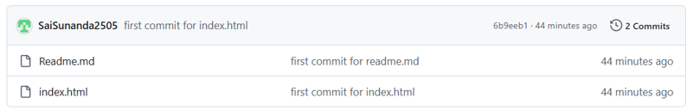

**SCENARIO 2:**

* **Cloning the GitHub repository**

garid@WINTERSOLDIER MINGW64 /d/sunanda/myfirstproject (main)

$ cd ..

garid@WINTERSOLDIER MINGW64 /d/sunanda

$ mkdir mysecondproject

garid@WINTERSOLDIER MINGW64 /d/sunanda

$ cd mysecondproject/

garid@WINTERSOLDIER MINGW64 /d/sunanda/mysecondproject

$ ls

garid@WINTERSOLDIER MINGW64 /d/sunanda/mysecondproject

$ git clone https://github.com/SaiSunanda2505/python-helloworld.git

Cloning into 'python-helloworld'...

remote: Enumerating objects: 56, done.

remote: Counting objects: 100% (22/22), done.

remote: Compressing objects: 100% (15/15), done.

remote: Total 56 (delta 13), reused 7 (delta 7), pack-reused 34 (from 1)

Receiving objects: 100% (56/56), 13.63 KiB | 2.73 MiB/s, done.

Resolving deltas: 100% (18/18), done.

garid@WINTERSOLDIER MINGW64 /d/sunanda/mysecondproject

$ ls

**python-helloworld**/

garid@WINTERSOLDIER MINGW64 /d/sunanda/mysecondproject

$ cd python-helloworld/

garid@WINTERSOLDIER MINGW64 /d/sunanda/mysecondproject/python-helloworld (main)

$ ls -a

**.**/ **.git**/ LICENSE README.md **helloworld**/ pyproject.toml

**..**/ .gitignore MANIFEST.in VERSION.txt **helloworld.py**\* setup.py

garid@WINTERSOLDIER MINGW64 /d/sunanda/mysecondproject/python-helloworld (main)

$ git status

On branch main

Your branch is up to date with 'origin/main'.

nothing to commit, working tree clean

garid@WINTERSOLDIER MINGW64 /d/sunanda/mysecondproject/python-helloworld (main)

$ vi helloworld.py

garid@WINTERSOLDIER MINGW64 /d/sunanda/mysecondproject/python-helloworld (main)

$ git status

On branch main

Your branch is up to date with 'origin/main'.

Changes not staged for commit:

(use "git add <file>..." to update what will be committed)

(use "git restore <file>..." to discard changes in working directory)

modified: helloworld.py

no changes added to commit (use "git add" and/or "git commit -a")

garid@WINTERSOLDIER MINGW64 /d/sunanda/mysecondproject/python-helloworld (main)

$ git add helloworld.py

garid@WINTERSOLDIER MINGW64 /d/sunanda/mysecondproject/python-helloworld (main)

$ git status

On branch main

Your branch is up to date with 'origin/main'.

Changes to be committed:

(use "git restore --staged <file>..." to unstage)

modified: helloworld.py

garid@WINTERSOLDIER MINGW64 /d/sunanda/mysecondproject/python-helloworld (main)

$ git config user.name SaiSunanda2505

garid@WINTERSOLDIER MINGW64 /d/sunanda/mysecondproject/python-helloworld (main)

$ git config user.email saisunanda2005@gmail.com

garid@WINTERSOLDIER MINGW64 /d/sunanda/mysecondproject/python-helloworld (main)

$ git commit -m "edited py doc"

[main e5b7a81] edited py doc

1 file changed, 1 insertion(+), 1 deletion(-)

garid@WINTERSOLDIER MINGW64 /d/sunanda/mysecondproject/python-helloworld (main)

$ git push

Enumerating objects: 5, done.

Counting objects: 100% (5/5), done.

Delta compression using up to 12 threads

Compressing objects: 100% (3/3), done.

Writing objects: 100% (3/3), 304 bytes | 304.00 KiB/s, done.

Total 3 (delta 2), reused 0 (delta 0), pack-reused 0 (from 0)

remote: Resolving deltas: 100% (2/2), completed with 2 local objects.

To https://github.com/SaiSunanda2505/python-helloworld.git

288d7ce..e5b7a81 main -> main

garid@WINTERSOLDIER MINGW64 /d/sunanda/mysecondproject/python-helloworld (main)

$ git status

On branch main

Your branch is up to date with 'origin/main'.

nothing to commit, working tree clean

garid@WINTERSOLDIER MINGW64 /d/sunanda/mysecondproject/python-helloworld (main)

$ git remote -v

origin https://github.com/SaiSunanda2505/python-helloworld.git (fetch)

origin https://github.com/SaiSunanda2505/python-helloworld.git (push)

garid@WINTERSOLDIER MINGW64 /d/sunanda/mysecondproject/python-helloworld (main)

$ git log

commit e5b7a81723cd01c22f855364ff6592d5b3c4f9c1 (**HEAD** -> **main**, **origin/main**, **origin/HEAD**)

Author: SaiSunanda2505 <saisunanda2005@gmail.com>

Date: Mon Nov 25 10:16:19 2024 +0530

edited py doc

commit 288d7ced1b971fd1b3b0c36002b96e1c3f91542e

Author: David Barnett <david@mumind.me>

Date: Fri Aug 16 17:45:24 2024 -0600

Move package metadata from setup.py into pyproject.toml

Details on pyproject.toml: PEP 621.

commit aed348ececb1860aa32e12ca9767b02e6dce8d21

Author: David Barnett <david@mumind.me>

Date: Fri Aug 16 17:57:57 2024 -0600

setup.py: genericize author name/email (to avoid copypasta of actual author details)

commit 90b8b0a324914aa39b9f51e778f8568fe8d4c9fa

Author: David Barnett <david@mumind.me>

Date: Fri Aug 16 17:40:57 2024 -0600

Expand README with more basic info and examples

commit f11a3ab588a48a70569b903d5ac13dc1219ff95e

Author: David Barnett <david@mumind.me>

Date: Fri Aug 16 17:04:23 2024 -0600

Rename README->README.md

commit 94dc2059a274cb85d50a3c1d2b81d06dd9d3848d

Author: msomula <72281440+msomula@users.noreply.github.com>

Date: Tue May 21 19:08:27 2024 -0400

Fix README typo (#25)

commit b5f571da86cf6b6d393f63d8d50abb53012883db

Author: David Barnett <davidbarnett2@gmail.com>

Date: Thu Jan 30 07:15:53 2020 -0800

Add --version and --help arguments using argparse (#11)

commit ad050ec68581bd76d4ccbc7570ff470fd1cbc110

Author: David Barnett <dbarnett@google.com>

Date: Mon Jan 27 20:47:38 2020 -0800

Also fix license value to Apache 2.0 in setup.py file

commit 66a010103dbc79d134af5a78cf6dd6e5301a6867

Author: David Barnett <dbarnett@google.com>

Date: Mon Jan 27 20:21:23 2020 -0800

License under Apache 2.0

commit 5c88293df450a8894fa0dd60d2e80456cd72c956

Author: David Barnett <davidbarnett2@gmail.com>

Date: Sun Jan 26 11:54:31 2020 -0800

.gitignore: Add a few missing ignore patterns for build output files

commit f8d7912a17e0b05b60899af0b4b7350406ef9946

Merge: 61b7a90 bb1f2d6

Author: David Barnett <davidbarnett2@gmail.com>

Date: Sat Jan 25 08:32:26 2020 -0800

Merge pull request #4 from haizaar/master

Python 3 support

garid@WINTERSOLDIER MINGW64 /d/sunanda/mysecondproject/python-helloworld (main)

$ git log --oneline

e5b7a81 (**HEAD** -> **main**, **origin/main**, **origin/HEAD**) edited py doc

288d7ce Move package metadata from setup.py into pyproject.toml

aed348e setup.py: genericize author name/email (to avoid copypasta of actual author details)

90b8b0a Expand README with more basic info and examples

f11a3ab Rename README->README.md

94dc205 Fix README typo (#25)

b5f571d Add --version and --help arguments using argparse (#11)

ad050ec Also fix license value to Apache 2.0 in setup.py file

66a0101 License under Apache 2.0

5c88293 .gitignore: Add a few missing ignore patterns for build output files

f8d7912 Merge pull request #4 from haizaar/master

61b7a90 Merge pull request #5 from HannHank/patch-1

4b50950 Update Readme

bb1f2d6 Python3 is here to stay

3ff0138 comments in setup.py

7a793c2 Initial: README, source, and setup.py

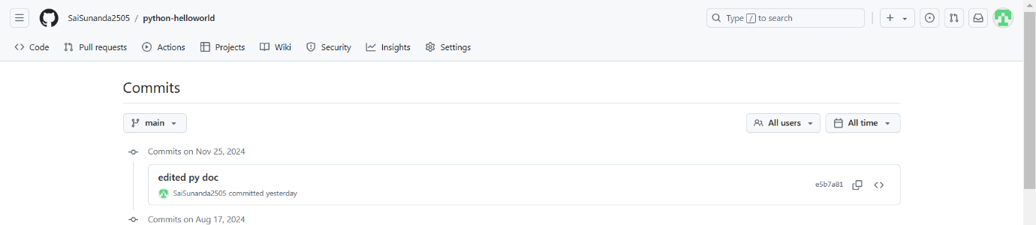

**SCENARIO 3:**

* **Git branches**

garid@WINTERSOLDIER MINGW64 /d/sunanda/mysecondproject/python-helloworld (main)

$ cd ..

garid@WINTERSOLDIER MINGW64 /d/sunanda/mysecondproject

$ cd ..

garid@WINTERSOLDIER MINGW64 /d/sunanda

$ cd myfirstproject/

garid@WINTERSOLDIER MINGW64 /d/sunanda/myfirstproject (main)

$ git branch

* main

garid@WINTERSOLDIER MINGW64 /d/sunanda/myfirstproject (main)

$ git branch developer

garid@WINTERSOLDIER MINGW64 /d/sunanda/myfirstproject (main)

$ git branch

developer

* main

garid@WINTERSOLDIER MINGW64 /d/sunanda/myfirstproject (main)

$ git checkout developer

Switched to branch 'developer'

M Readme.md

garid@WINTERSOLDIER MINGW64 /d/sunanda/myfirstproject (developer)

$ git log --oneline

6b9eeb1 (**HEAD** -> **developer**, **origin/main**, **main**) first commit for index.html

46b8cf0 first commit for readme.md

garid@WINTERSOLDIER MINGW64 /d/sunanda/myfirstproject (developer)

$ touch index.jsp

garid@WINTERSOLDIER MINGW64 /d/sunanda/myfirstproject (developer)

$ cat>> index.jsp

created index.jsp first file in dev branch

garid@WINTERSOLDIER MINGW64 /d/sunanda/myfirstproject (developer)

$ git add index.jsp

warning: in the working copy of 'index.jsp', LF will be replaced by CRLF the next time Git touches it

garid@WINTERSOLDIER MINGW64 /d/sunanda/myfirstproject (developer)

$ git add index.jsp

garid@WINTERSOLDIER MINGW64 /d/sunanda/myfirstproject (developer)

$ git commit -m "first commit for jsp in dev"

[developer a0fad50] first commit for jsp in dev

2 files changed, 2 insertions(+)

create mode 100644 index.jsp

garid@WINTERSOLDIER MINGW64 /d/sunanda/myfirstproject (developer)

$ git log --oneline

a0fad50 (**HEAD** -> **developer**) first commit for jsp in dev

6b9eeb1 (**origin/main**, **main**) first commit for index.html

46b8cf0 first commit for readme.md

garid@WINTERSOLDIER MINGW64 /d/sunanda/myfirstproject (developer)

$ touch Readme.doc

garid@WINTERSOLDIER MINGW64 /d/sunanda/myfirstproject (developer)

$ git add .

garid@WINTERSOLDIER MINGW64 /d/sunanda/myfirstproject (developer)

$ git commit -m "read doc commit in dev"

[developer c03270a] read doc commit in dev

1 file changed, 0 insertions(+), 0 deletions(-)

create mode 100644 Readme.doc

garid@WINTERSOLDIER MINGW64 /d/sunanda/myfirstproject (developer)

$ git log --oneline

c03270a (**HEAD** -> **developer**) read doc commit in dev

a0fad50 first commit for jsp in dev

6b9eeb1 (**origin/main**, **main**) first commit for index.html

46b8cf0 first commit for readme.md

garid@WINTERSOLDIER MINGW64 /d/sunanda/myfirstproject (developer)

$ git log --oneline --graph --all --decorate

* c03270a (**HEAD** -> **developer**) read doc commit in dev

* a0fad50 first commit for jsp in dev

* 6b9eeb1 (**origin/main**, **main**) first commit for index.html

* 46b8cf0 first commit for readme.md

garid@WINTERSOLDIER MINGW64 /d/sunanda/myfirstproject (developer)

$ git checkout main

Switched to branch 'main'

Your branch is up to date with 'origin/main'.

garid@WINTERSOLDIER MINGW64 /d/sunanda/myfirstproject (main)

$ git log --oneline --graph --all --decorate

* c03270a (**developer**) read doc commit in dev

* a0fad50 first commit for jsp in dev

* 6b9eeb1 (**HEAD** -> **main**, **origin/main**) first commit for index.html

* 46b8cf0 first commit for readme.md

garid@WINTERSOLDIER MINGW64 /d/sunanda/myfirstproject (main)

$ git log --oneline --graph

* 6b9eeb1 (**HEAD** -> **main**, **origin/main**) first commit for index.html

* 46b8cf0 first commit for readme.md

garid@WINTERSOLDIER MINGW64 /d/sunanda/myfirstproject (main)

$ ls

Readme.md index.html

garid@WINTERSOLDIER MINGW64 /d/sunanda/myfirstproject (main)

$ vi Readme.md

garid@WINTERSOLDIER MINGW64 /d/sunanda/myfirstproject (main)

$ vi index.html

garid@WINTERSOLDIER MINGW64 /d/sunanda/myfirstproject (main)

$ git add Readme.md

garid@WINTERSOLDIER MINGW64 /d/sunanda/myfirstproject (main)

$ git commit -m "main commit for readme.md"

[main 7d81cb1] main commit for readme.md

1 file changed, 2 insertions(+)

garid@WINTERSOLDIER MINGW64 /d/sunanda/myfirstproject (main)

$ git add index.html

warning: in the working copy of 'index.html', LF will be replaced by CRLF the next time Git touches it

garid@WINTERSOLDIER MINGW64 /d/sunanda/myfirstproject (main)

$ git add index.html

garid@WINTERSOLDIER MINGW64 /d/sunanda/myfirstproject (main)

$ git commit -m "main commit for index.html"

[main 524a5f2] main commit for index.html

1 file changed, 5 insertions(+)

garid@WINTERSOLDIER MINGW64 /d/sunanda/myfirstproject (main)

$ git status

On branch main

Your branch is ahead of 'origin/main' by 2 commits.

(use "git push" to publish your local commits)

nothing to commit, working tree clean

garid@WINTERSOLDIER MINGW64 /d/sunanda/myfirstproject (main)

$ git log --oneline

524a5f2 (**HEAD** -> **main**) main commit for index.html

7d81cb1 main commit for readme.md

6b9eeb1 (**origin/main**) first commit for index.html

46b8cf0 first commit for readme.md

garid@WINTERSOLDIER MINGW64 /d/sunanda/myfirstproject (main)

$ git checkout developer

Switched to branch 'developer'

garid@WINTERSOLDIER MINGW64 /d/sunanda/myfirstproject (developer)

$ git merge main

Auto-merging Readme.md

Merge made by the 'ort' strategy.

Readme.md | 2 ++

index.html | 5 +++++

2 files changed, 7 insertions(+)

garid@WINTERSOLDIER MINGW64 /d/sunanda/myfirstproject (developer)

$ git status

On branch developer

nothing to commit, working tree clean

garid@WINTERSOLDIER MINGW64 /d/sunanda/myfirstproject (developer)

$ git log --oneline --graph --all --decorate

* 1aa56db (**HEAD** -> **developer**) Merge branch 'main' into developer merging

|\

| * 524a5f2 (**main**) main commit for index.html

| * 7d81cb1 main commit for readme.md

* | c03270a read doc commit in dev

* | a0fad50 first commit for jsp in dev

|/

* 6b9eeb1 (**origin/main**) first commit for index.html

* 46b8cf0 first commit for readme.md

garid@WINTERSOLDIER MINGW64 /d/sunanda/myfirstproject (developer)

$ git merge main

Already up to date.

garid@WINTERSOLDIER MINGW64 /d/sunanda/myfirstproject (developer)

$ touch f1 f2

garid@WINTERSOLDIER MINGW64 /d/sunanda/myfirstproject (developer)

$ git add f1

garid@WINTERSOLDIER MINGW64 /d/sunanda/myfirstproject (developer)

$ git commit -m "f1 created"

[developer 5cac535] f1 created

1 file changed, 0 insertions(+), 0 deletions(-)

create mode 100644 f1

garid@WINTERSOLDIER MINGW64 /d/sunanda/myfirstproject (developer)

$ git add f2

garid@WINTERSOLDIER MINGW64 /d/sunanda/myfirstproject (developer)

$ git commit -m "f2created"

[developer 91dda37] f2created

1 file changed, 0 insertions(+), 0 deletions(-)

create mode 100644 f2

garid@WINTERSOLDIER MINGW64 /d/sunanda/myfirstproject (developer)

$ git log --oneline --graph --all --decorate

* 91dda37 (**HEAD** -> **developer**) f2created

* 5cac535 f1 created

* 1aa56db Merge branch 'main' into developer merging

|\

| * 524a5f2 (**main**) main commit for index.html

| * 7d81cb1 main commit for readme.md

* | c03270a read doc commit in dev

* | a0fad50 first commit for jsp in dev

|/

* 6b9eeb1 (**origin/main**) first commit for index.html

* 46b8cf0 first commit for readme.md

garid@WINTERSOLDIER MINGW64 /d/sunanda/myfirstproject (developer)

$ git checkout main

Switched to branch 'main'

Your branch is ahead of 'origin/main' by 2 commits.

(use "git push" to publish your local commits)

garid@WINTERSOLDIER MINGW64 /d/sunanda/myfirstproject (main)

$ git merge developer

Updating 524a5f2..91dda37

Fast-forward

Readme.doc | 0

Readme.md | 1 +

f1 | 0

f2 | 0

index.jsp | 1 +

5 files changed, 2 insertions(+)

create mode 100644 Readme.doc

create mode 100644 f1

create mode 100644 f2

create mode 100644 index.jsp

garid@WINTERSOLDIER MINGW64 /d/sunanda/myfirstproject (main)

$ git log --oneline --graph --all --decorate

* 91dda37 (**HEAD** -> **main**, **developer**) f2created

* 5cac535 f1 created

* 1aa56db Merge branch 'main' into developer merging

|\

| * 524a5f2 main commit for index.html

| * 7d81cb1 main commit for readme.md

* | c03270a read doc commit in dev

* | a0fad50 first commit for jsp in dev

|/

* 6b9eeb1 (**origin/main**) first commit for index.html

* 46b8cf0 first commit for readme.md

**SCENARIO 4:**

* **Git Rebase**

garid@WINTERSOLDIER MINGW64 /d/sunanda/myfirstproject (main)

$ git branch hotfix

garid@WINTERSOLDIER MINGW64 /d/sunanda/myfirstproject (main)

$ touch r1 r2

garid@WINTERSOLDIER MINGW64 /d/sunanda/myfirstproject (main)

$ git add r1

garid@WINTERSOLDIER MINGW64 /d/sunanda/myfirstproject (main)

$ git commit -m "first commit for rebase"

[main 100dcfd] first commit for rebase

1 file changed, 0 insertions(+), 0 deletions(-)

create mode 100644 r1

garid@WINTERSOLDIER MINGW64 /d/sunanda/myfirstproject (main)

$ git add r2

garid@WINTERSOLDIER MINGW64 /d/sunanda/myfirstproject (main)

$ git commit -m "second commit for rebase"

[main cc4da88] second commit for rebase

1 file changed, 0 insertions(+), 0 deletions(-)

create mode 100644 r2

garid@WINTERSOLDIER MINGW64 /d/sunanda/myfirstproject (main)

$ git checkout hotfix

Switched to branch 'hotfix'

garid@WINTERSOLDIER MINGW64 /d/sunanda/myfirstproject (hotfix)

$ touch h1 h2

garid@WINTERSOLDIER MINGW64 /d/sunanda/myfirstproject (hotfix)

$ git add h1

garid@WINTERSOLDIER MINGW64 /d/sunanda/myfirstproject (hotfix)

$ git commit -m "h1 commit in hotfix"

[hotfix 586a50a] h1 commit in hotfix

1 file changed, 0 insertions(+), 0 deletions(-)

create mode 100644 h1

garid@WINTERSOLDIER MINGW64 /d/sunanda/myfirstproject (hotfix)

$ git add h2

garid@WINTERSOLDIER MINGW64 /d/sunanda/myfirstproject (hotfix)

$ git commit -m "h2 commit in hotfix"

[hotfix a7a0a89] h2 commit in hotfix

1 file changed, 0 insertions(+), 0 deletions(-)

create mode 100644 h2

garid@WINTERSOLDIER MINGW64 /d/sunanda/myfirstproject (hotfix)

$ git log --oneline --graph --all --decorate

* a7a0a89 (**HEAD** -> **hotfix**) h2 commit in hotfix

* 586a50a h1 commit in hotfix

| * cc4da88 (**main**) second commit for rebase

| * 100dcfd first commit for rebase

|/

* 91dda37 (**developer**) f2created

* 5cac535 f1 created

* 1aa56db Merge branch 'main' into developer merging

|\

| * 524a5f2 main commit for index.html

| * 7d81cb1 main commit for readme.md

* | c03270a read doc commit in dev

* | a0fad50 first commit for jsp in dev

|/

* 6b9eeb1 (**origin/main**) first commit for index.html

* 46b8cf0 first commit for readme.md

garid@WINTERSOLDIER MINGW64 /d/sunanda/myfirstproject (hotfix)

$ git rebase main

Successfully rebased and updated refs/heads/hotfix.

garid@WINTERSOLDIER MINGW64 /d/sunanda/myfirstproject (hotfix)

$ git log --oneline --graph --all --decorate

* 454cf8f (**HEAD** -> **hotfix**) h2 commit in hotfix

* 4bcce6f h1 commit in hotfix

* cc4da88 (**main**) second commit for rebase

* 100dcfd first commit for rebase

* 91dda37 (**developer**) f2created

* 5cac535 f1 created

* 1aa56db Merge branch 'main' into developer merging

|\

| * 524a5f2 main commit for index.html

| * 7d81cb1 main commit for readme.md

* | c03270a read doc commit in dev

* | a0fad50 first commit for jsp in dev

|/

* 6b9eeb1 (**origin/main**) first commit for index.html

* 46b8cf0 first commit for readme.md

garid@WINTERSOLDIER MINGW64 /d/sunanda/myfirstproject (hotfix)

$ git checkout main

Switched to branch 'main'

Your branch is ahead of 'origin/main' by 9 commits.

(use "git push" to publish your local commits)

garid@WINTERSOLDIER MINGW64 /d/sunanda/myfirstproject (main)

$ git branch

developer

hotfix

* main

garid@WINTERSOLDIER MINGW64 /d/sunanda/myfirstproject (main)

$ git push origin developer

Enumerating objects: 22, done.

Counting objects: 100% (22/22), done.

Delta compression using up to 12 threads

Compressing objects: 100% (14/14), done.

Writing objects: 100% (19/19), 1.81 KiB | 1.81 MiB/s, done.

Total 19 (delta 4), reused 0 (delta 0), pack-reused 0 (from 0)

remote: Resolving deltas: 100% (4/4), done.

remote:

remote: Create a pull request for 'developer' on GitHub by visiting:

remote: https://github.com/SaiSunanda2505/myfirstproject1/pull/new/developer

remote:

To https://github.com/SaiSunanda2505/myfirstproject1.git

* [new branch] developer -> developer

garid@WINTERSOLDIER MINGW64 /d/sunanda/myfirstproject (main)

$ git push origin hotfix

Enumerating objects: 9, done.

Counting objects: 100% (9/9), done.

Delta compression using up to 12 threads

Compressing objects: 100% (8/8), done.

Writing objects: 100% (8/8), 800 bytes | 800.00 KiB/s, done.

Total 8 (delta 4), reused 0 (delta 0), pack-reused 0 (from 0)

remote: Resolving deltas: 100% (4/4), completed with 1 local object.

remote:

remote: Create a pull request for 'hotfix' on GitHub by visiting:

remote: https://github.com/SaiSunanda2505/myfirstproject1/pull/new/hotfix

remote:

To https://github.com/SaiSunanda2505/myfirstproject1.git

* [new branch] hotfix -> hotfix

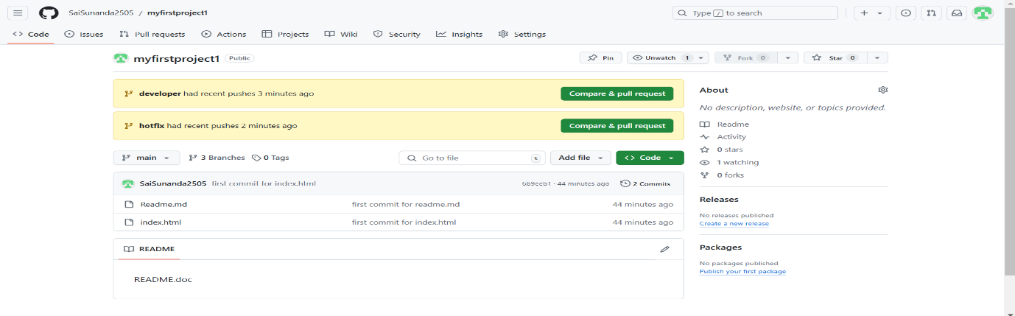

**SCENARIO 5:**

* **Git Squash**

garid@WINTERSOLDIER MINGW64 /d/sunanda

$ git clone https://github.com/SaiSunanda2505/gitsquash1.git

Cloning into 'gitsquash1'...

warning: You appear to have cloned an empty repository.

garid@WINTERSOLDIER MINGW64 /d/sunanda

$ cd gitsquash1/

garid@WINTERSOLDIER MINGW64 /d/sunanda/gitsquash1 (main)

$ touch f1 f2 f3 f4 f5

garid@WINTERSOLDIER MINGW64 /d/sunanda/gitsquash1 (main)

$ git config user.name SaiSunanda2505

garid@WINTERSOLDIER MINGW64 /d/sunanda/gitsquash1 (main)

$ git config user.email saisunanda2005@gmail.com

garid@WINTERSOLDIER MINGW64 /d/sunanda/gitsquash1 (main)

$ git add f1

garid@WINTERSOLDIER MINGW64 /d/sunanda/gitsquash1 (main)

$ git commit -m "f1 in main"

[main (root-commit) 2bc1b87] f1 in main

1 file changed, 0 insertions(+), 0 deletions(-)

create mode 100644 f1

garid@WINTERSOLDIER MINGW64 /d/sunanda/gitsquash1 (main)

$ git add f2

garid@WINTERSOLDIER MINGW64 /d/sunanda/gitsquash1 (main)

$ git commit -m "f2 in main"

[main e5558d8] f2 in main

1 file changed, 0 insertions(+), 0 deletions(-)

create mode 100644 f2

garid@WINTERSOLDIER MINGW64 /d/sunanda/gitsquash1 (main)

$ git add f3

garid@WINTERSOLDIER MINGW64 /d/sunanda/gitsquash1 (main)

$ git commit -m "f3 in main"

[main d213a91] f3 in main

1 file changed, 0 insertions(+), 0 deletions(-)

create mode 100644 f3

garid@WINTERSOLDIER MINGW64 /d/sunanda/gitsquash1 (main)

$ git add f4

garid@WINTERSOLDIER MINGW64 /d/sunanda/gitsquash1 (main)

$ git branch bugfix

garid@WINTERSOLDIER MINGW64 /d/sunanda/gitsquash1 (main)

$ git branch

bugfix

* main

garid@WINTERSOLDIER MINGW64 /d/sunanda/gitsquash1 (main)

$ git commit -m "f4 in main"

[main 4b39102] f4 in main

1 file changed, 0 insertions(+), 0 deletions(-)

create mode 100644 f4

garid@WINTERSOLDIER MINGW64 /d/sunanda/gitsquash1 (main)

$ git switch bugfix

Switched to branch 'bugfix'

garid@WINTERSOLDIER MINGW64 /d/sunanda/gitsquash1 (bugfix)

$ touch b1 b2 b3 b4 b5

garid@WINTERSOLDIER MINGW64 /d/sunanda/gitsquash1 (bugfix)

$ git add b1

garid@WINTERSOLDIER MINGW64 /d/sunanda/gitsquash1 (bugfix)

$ git commit -m "b1 in bugfix"

[bugfix 2b0705a] b1 in bugfix

1 file changed, 0 insertions(+), 0 deletions(-)

create mode 100644 b1

garid@WINTERSOLDIER MINGW64 /d/sunanda/gitsquash1 (bugfix)

$ git add b2

garid@WINTERSOLDIER MINGW64 /d/sunanda/gitsquash1 (bugfix)

$ git commit -m "b2 in bugfix"

[bugfix e37865a] b2 in bugfix

1 file changed, 0 insertions(+), 0 deletions(-)

create mode 100644 b2

garid@WINTERSOLDIER MINGW64 /d/sunanda/gitsquash1 (bugfix)

$ git add b3

garid@WINTERSOLDIER MINGW64 /d/sunanda/gitsquash1 (bugfix)

$ git commit -m "b3 in bugfix"

[bugfix 4e2e5f6] b3 in bugfix

1 file changed, 0 insertions(+), 0 deletions(-)

create mode 100644 b3

garid@WINTERSOLDIER MINGW64 /d/sunanda/gitsquash1 (bugfix)

$ git add b4

garid@WINTERSOLDIER MINGW64 /d/sunanda/gitsquash1 (bugfix)

$ git commit -m "b4 in bugfix"

[bugfix 6aaddf6] b4 in bugfix

1 file changed, 0 insertions(+), 0 deletions(-)

create mode 100644 b4

garid@WINTERSOLDIER MINGW64 /d/sunanda/gitsquash1 (bugfix)

$ git config alias.allc "log --oneline --graph --all --decorate"

garid@WINTERSOLDIER MINGW64 /d/sunanda/gitsquash1 (bugfix)

$ git allc

* 6aaddf6 (**HEAD** -> **bugfix**) b4 in bugfix

* 4e2e5f6 b3 in bugfix

* e37865a b2 in bugfix

* 2b0705a b1 in bugfix

| * 4b39102 (**main**) f4 in main

|/

* d213a91 f3 in main

* e5558d8 f2 in main

* 2bc1b87 f1 in main

garid@WINTERSOLDIER MINGW64 /d/sunanda/gitsquash1 (bugfix)

$ git rebase -i HEAD~3

[detached HEAD 40c54b1] b2 in bugfix

Date: Mon Nov 25 19:30:48 2024 +0530

3 files changed, 0 insertions(+), 0 deletions(-)

create mode 100644 b2

create mode 100644 b3

create mode 100644 b4

Successfully rebased and updated refs/heads/bugfix.

garid@WINTERSOLDIER MINGW64 /d/sunanda/gitsquash1 (bugfix)

$ git allc

* 40c54b1 (**HEAD** -> **bugfix**) b2 in bugfix

* 2b0705a b1 in bugfix

| * 4b39102 (**main**) f4 in main

|/

* d213a91 f3 in main

* e5558d8 f2 in main

* 2bc1b87 f1 in main

garid@WINTERSOLDIER MINGW64 /d/sunanda/gitsquash1 (bugfix)

$ git log

commit 40c54b1e64c8296bb9553619388d3b102ad29982 (**HEAD** -> **bugfix**)

Author: SaiSunanda2505 <saisunanda2005@gmail.com>

Date: Mon Nov 25 19:30:48 2024 +0530

b2 in bugfix

3,4 commits merged using squash

commit 2b0705a86079357ac4208304b1a3fe149f9ca779

Author: SaiSunanda2505 <saisunanda2005@gmail.com>

Date: Mon Nov 25 19:30:33 2024 +0530

b1 in bugfix

commit d213a91baa2293a6a8543910dace91aa19fb7db8

Author: SaiSunanda2505 <saisunanda2005@gmail.com>

Date: Mon Nov 25 19:29:08 2024 +0530

f3 in main

commit e5558d80b11ddfb1abbc8cbc841183aa0347e240

Author: SaiSunanda2505 <saisunanda2005@gmail.com>

Date: Mon Nov 25 19:28:55 2024 +0530

f2 in main

commit 2bc1b87f49715f8242d6e447a15af35fc3049cdb

Author: SaiSunanda2505 <saisunanda2005@gmail.com>

Date: Mon Nov 25 19:28:47 2024 +0530

f1 in main

garid@WINTERSOLDIER MINGW64 /d/sunanda/gitsquash1 (bugfix)

$ git status

On branch bugfix

Untracked files:

(use "git add <file>..." to include in what will be committed)

b5

f5

nothing added to commit but untracked files present (use "git add" to track)

garid@WINTERSOLDIER MINGW64 /d/sunanda/gitsquash1 (bugfix)

$ git add b5

garid@WINTERSOLDIER MINGW64 /d/sunanda/gitsquash1 (bugfix)

$ git commit -m "b5 in bugfix"

[bugfix b7b2e4e] b5 in bugfix

1 file changed, 0 insertions(+), 0 deletions(-)

create mode 100644 b5

garid@WINTERSOLDIER MINGW64 /d/sunanda/gitsquash1 (bugfix)

$ git allc

* b7b2e4e (**HEAD** -> **bugfix**) b5 in bugfix

* 40c54b1 b2 in bugfix

* 2b0705a b1 in bugfix

| * 4b39102 (**main**) f4 in main

|/

* d213a91 f3 in main

* e5558d8 f2 in main

* 2bc1b87 f1 in main

garid@WINTERSOLDIER MINGW64 /d/sunanda/gitsquash1 (bugfix)

$ git switch main

Switched to branch 'main'

Your branch is based on 'origin/main', but the upstream is gone.

(use "git branch --unset-upstream" to fixup)

garid@WINTERSOLDIER MINGW64 /d/sunanda/gitsquash1 (main)

$ git allc

* b7b2e4e (**bugfix**) b5 in bugfix

* 40c54b1 b2 in bugfix

* 2b0705a b1 in bugfix

| * 4b39102 (**HEAD** -> **main**) f4 in main

|/

* d213a91 f3 in main

* e5558d8 f2 in main

* 2bc1b87 f1 in main

garid@WINTERSOLDIER MINGW64 /d/sunanda/gitsquash1 (main)

$ git merge --squash bugfix

Automatic merge went well; stopped before committing as requested

Squash commit -- not updating HEAD

garid@WINTERSOLDIER MINGW64 /d/sunanda/gitsquash1 (main)

$ git add f5

garid@WINTERSOLDIER MINGW64 /d/sunanda/gitsquash1 (main)

$ git commit -m "f5 in main"

[main c11d34e] f5 in main

6 files changed, 0 insertions(+), 0 deletions(-)

create mode 100644 b1

create mode 100644 b2

create mode 100644 b3

create mode 100644 b4

create mode 100644 b5

create mode 100644 f5

garid@WINTERSOLDIER MINGW64 /d/sunanda/gitsquash1 (main)

$ git allc

* c11d34e (**HEAD** -> **main**) f5 in main

* 4b39102 f4 in main

| * b7b2e4e (**bugfix**) b5 in bugfix

| * 40c54b1 b2 in bugfix

| * 2b0705a b1 in bugfix

|/

* d213a91 f3 in main

* e5558d8 f2 in main

* 2bc1b87 f1 in main

garid@WINTERSOLDIER MINGW64 /d/sunanda/gitsquash1 (main)

$ git merge --squash bugfix

Automatic merge went well; stopped before committing as requested

Squash commit -- not updating HEAD

**SCENARIO 6:**

* **Git Diff**

garid@WINTERSOLDIER MINGW64 /d/sunanda/gitsquash1 (main)

$ git diff

garid@WINTERSOLDIER MINGW64 /d/sunanda/gitsquash1 (main)

$ git status

On branch main

Your branch is based on 'origin/main', but the upstream is gone.

(use "git branch --unset-upstream" to fixup)

nothing to commit, working tree clean

garid@WINTERSOLDIER MINGW64 /d/sunanda/gitsquash1 (main)

$ ls

b1 b2 b3 b4 b5 f1 f2 f3 f4 f5

garid@WINTERSOLDIER MINGW64 /d/sunanda/gitsquash1 (main)

$ touch f6

garid@WINTERSOLDIER MINGW64 /d/sunanda/gitsquash1 (main)

$ git status

On branch main

Your branch is based on 'origin/main', but the upstream is gone.

(use "git branch --unset-upstream" to fixup)

Untracked files:

(use "git add <file>..." to include in what will be committed)

f6

nothing added to commit but untracked files present (use "git add" to track)

garid@WINTERSOLDIER MINGW64 /d/sunanda/gitsquash1 (main)

$ vi f6

garid@WINTERSOLDIER MINGW64 /d/sunanda/gitsquash1 (main)

$ cat>> f1

created f1

garid@WINTERSOLDIER MINGW64 /d/sunanda/gitsquash1 (main)

$ git status

On branch main

Your branch is based on 'origin/main', but the upstream is gone.

(use "git branch --unset-upstream" to fixup)

Changes not staged for commit:

(use "git add <file>..." to update what will be committed)

(use "git restore <file>..." to discard changes in working directory)

modified: f1

Untracked files:

(use "git add <file>..." to include in what will be committed)

f6

no changes added to commit (use "git add" and/or "git commit -a")

garid@WINTERSOLDIER MINGW64 /d/sunanda/gitsquash1 (main)

$ git diff

warning: in the working copy of 'f1', LF will be replaced by CRLF the next time Git touches it

**diff --git a/f1 b/f1**

**index e69de29..f989cf9 100644**

**--- a/f1**

**+++ b/f1**

@@ -0,0 +1 @@

+created f1

garid@WINTERSOLDIER MINGW64 /d/sunanda/gitsquash1 (main)

$ cat>> f1

added line

garid@WINTERSOLDIER MINGW64 /d/sunanda/gitsquash1 (main)

$ git diff

warning: in the working copy of 'f1', LF will be replaced by CRLF the next time Git touches it

**diff --git a/f1 b/f1**

**index e69de29..391a453 100644**

**--- a/f1**

**+++ b/f1**

@@ -0,0 +1,2 @@

+created f1

+added line

garid@WINTERSOLDIER MINGW64 /d/sunanda/gitsquash1 (main)

$ git commit -m "f1 again in main"

On branch main

Your branch is based on 'origin/main', but the upstream is gone.

(use "git branch --unset-upstream" to fixup)

Changes not staged for commit:

(use "git add <file>..." to update what will be committed)

(use "git restore <file>..." to discard changes in working directory)

modified: f1

Untracked files:

(use "git add <file>..." to include in what will be committed)

f6

no changes added to commit (use "git add" and/or "git commit -a")

garid@WINTERSOLDIER MINGW64 /d/sunanda/gitsquash1 (main)

$ git add f1

warning: in the working copy of 'f1', LF will be replaced by CRLF the next time Git touches it

garid@WINTERSOLDIER MINGW64 /d/sunanda/gitsquash1 (main)

$ git add f1

garid@WINTERSOLDIER MINGW64 /d/sunanda/gitsquash1 (main)

$ git commit -m "f1 again in main"

[main 6f2c886] f1 again in main

1 file changed, 2 insertions(+)

garid@WINTERSOLDIER MINGW64 /d/sunanda/gitsquash1 (main)

$ cat>> f1

line 3

garid@WINTERSOLDIER MINGW64 /d/sunanda/gitsquash1 (main)

$ git commit -m "f1 again3 in main"

On branch main

Your branch is based on 'origin/main', but the upstream is gone.

(use "git branch --unset-upstream" to fixup)

Changes not staged for commit:

(use "git add <file>..." to update what will be committed)

(use "git restore <file>..." to discard changes in working directory)

modified: f1

Untracked files:

(use "git add <file>..." to include in what will be committed)

f6

no changes added to commit (use "git add" and/or "git commit -a")

garid@WINTERSOLDIER MINGW64 /d/sunanda/gitsquash1 (main)

$ git add f1

warning: in the working copy of 'f1', LF will be replaced by CRLF the next time Git touches it

garid@WINTERSOLDIER MINGW64 /d/sunanda/gitsquash1 (main)

$ git add f1

garid@WINTERSOLDIER MINGW64 /d/sunanda/gitsquash1 (main)

$ git commit -m "f1 again3 in main"

[main ddf0cf8] f1 again3 in main

1 file changed, 1 insertion(+)

garid@WINTERSOLDIER MINGW64 /d/sunanda/gitsquash1 (main)

$ cat>> f1

4 for f1

garid@WINTERSOLDIER MINGW64 /d/sunanda/gitsquash1 (main)

$ git add f1

warning: in the working copy of 'f1', LF will be replaced by CRLF the next time Git touches it

garid@WINTERSOLDIER MINGW64 /d/sunanda/gitsquash1 (main)

$ git add f1

garid@WINTERSOLDIER MINGW64 /d/sunanda/gitsquash1 (main)

$ git commit -m "f1 again4 in main"

[main f04b66b] f1 again4 in main

1 file changed, 1 insertion(+)

garid@WINTERSOLDIER MINGW64 /d/sunanda/gitsquash1 (main)

$ git allc

* f04b66b (**HEAD** -> **main**) f1 again4 in main

* ddf0cf8 f1 again3 in main

* 6f2c886 f1 again in main

* c11d34e f5 in main

* 4b39102 f4 in main

| * b7b2e4e (**bugfix**) b5 in bugfix

| * 40c54b1 b2 in bugfix

| * 2b0705a b1 in bugfix

|/

* d213a91 f3 in main

* e5558d8 f2 in main

* 2bc1b87 f1 in main

**SCENARIO 7:**

* **Git Tag**

garid@WINTERSOLDIER MINGW64 /d/sunanda/gitsquash1 (main)

$ git tag v3.0

garid@WINTERSOLDIER MINGW64 /d/sunanda/gitsquash1 (main)

$ git allc

* f04b66b (**HEAD** -> **main**, **tag: v3.0**) f1 again4 in main

* ddf0cf8 f1 again3 in main

* 6f2c886 f1 again in main

* c11d34e f5 in main

* 4b39102 f4 in main

| * b7b2e4e (**bugfix**) b5 in bugfix

| * 40c54b1 b2 in bugfix

| * 2b0705a b1 in bugfix

|/

* d213a91 f3 in main

* e5558d8 f2 in main

* 2bc1b87 f1 in main

garid@WINTERSOLDIER MINGW64 /d/sunanda/gitsquash1 (main)

$ git tag v2.0 b7b2e4e

garid@WINTERSOLDIER MINGW64 /d/sunanda/gitsquash1 (main)

$ git allc

* f04b66b (**HEAD** -> **main**, **tag: v3.0**) f1 again4 in main

* ddf0cf8 f1 again3 in main

* 6f2c886 f1 again in main

* c11d34e f5 in main

* 4b39102 f4 in main

| * b7b2e4e (**tag: v2.0**, **bugfix**) b5 in bugfix

| * 40c54b1 b2 in bugfix

| * 2b0705a b1 in bugfix

|/

* d213a91 f3 in main

* e5558d8 f2 in main

* 2bc1b87 f1 in main

garid@WINTERSOLDIER MINGW64 /d/sunanda/gitsquash1 (main)

$ git tag v1.0 d213a91

garid@WINTERSOLDIER MINGW64 /d/sunanda/gitsquash1 (main)

$ git allc

* f04b66b (**HEAD** -> **main**, **tag: v3.0**) f1 again4 in main

* ddf0cf8 f1 again3 in main

* 6f2c886 f1 again in main

* c11d34e f5 in main

* 4b39102 f4 in main

| * b7b2e4e (**tag: v2.0**, **bugfix**) b5 in bugfix

| * 40c54b1 b2 in bugfix

| * 2b0705a b1 in bugfix

|/

* d213a91 (**tag: v1.0**) f3 in main

* e5558d8 f2 in main

* 2bc1b87 f1 in main

garid@WINTERSOLDIER MINGW64 /d/sunanda/gitsquash1 (main)

$ git diff v3.0 v2.0

**diff --git a/f1 b/f1**

**index 95dc2f0..e69de29 100644**

**--- a/f1**

**+++ b/f1**

@@ -1,4 +0,0 @@

-created f1

-added line

-line 3

-4 for f1

**diff --git a/f4 b/f4**

**deleted file mode 100644**

**index e69de29..0000000**

**diff --git a/f5 b/f5**

**deleted file mode 100644**

**index e69de29..0000000**

garid@WINTERSOLDIER MINGW64 /d/sunanda/gitsquash1 (main)

$ ls

b1 b2 b3 b4 b5 f1 f2 f3 f4 f5 f6

**SCENARIO 8:**

* **Multiple developers working on the same repository**

**In cmd (developer 2)**

D:\>cd sunanda

D:\sunanda>mkdir dev2

D:\sunanda>cd dev2

D:\sunanda\dev2>git clone https://github.com/SaiSunanda2505/gitsquash1.git

Cloning into 'gitsquash1'...

warning: You appear to have cloned an empty repository.

D:\sunanda\dev2>cd gitsquash1

D:\sunanda\dev2\gitsquash1>git config user.name developer2

D:\sunanda\dev2\gitsquash1>git config user.email developer2@gmail.com

D:\sunanda\dev2\gitsquash1>git add index.html

D:\sunanda\dev2\gitsquash1>git commit -m "commited by dev2"

[main (root-commit) c01e6e4] commited by dev2

1 file changed, 5 insertions(+)

create mode 100644 index.html

D:\sunanda\dev2\gitsquash1>git push origin main

Enumerating objects: 3, done.

Counting objects: 100% (3/3), done.

Delta compression using up to 12 threads

Compressing objects: 100% (2/2), done.

Writing objects: 100% (3/3), 248 bytes | 124.00 KiB/s, done.

Total 3 (delta 0), reused 0 (delta 0), pack-reused 0 (from 0)

To https://github.com/SaiSunanda2505/gitsquash1.git

* [new branch] main -> main

* **As of now developer 1 didn’t push anything so push went smoothly**
* **Now if developer 1 tries to push he’ll face conflicts**

garid@WINTERSOLDIER MINGW64 /d/sunanda/gitsquash1 (main)

$ ls

b1 b2 b3 b4 b5 f1 f2 f3 f4 f5 f6

garid@WINTERSOLDIER MINGW64 /d/sunanda/gitsquash1 (main)

$ git push origin main

To https://github.com/SaiSunanda2505/gitsquash1.git

! [rejected] main -> main (fetch first)

error: failed to push some refs to 'https://github.com/SaiSunanda2505/gitsquash1.git'

hint: Updates were rejected because the remote contains work that you do not

hint: have locally. This is usually caused by another repository pushing to

hint: the same ref. If you want to integrate the remote changes, use

hint: 'git pull' before pushing again.

hint: See the 'Note about fast-forwards' in 'git push --help' for details.

* **Now to resolve this developer 1 has to update by pull**

garid@WINTERSOLDIER MINGW64 /d/sunanda/gitsquash1 (main)

$ git pull origin main

remote: Enumerating objects: 3, done.

remote: Counting objects: 100% (3/3), done.

remote: Compressing objects: 100% (2/2), done.

remote: Total 3 (delta 0), reused 3 (delta 0), pack-reused 0 (from 0)

Unpacking objects: 100% (3/3), 228 bytes | 38.00 KiB/s, done.

From https://github.com/SaiSunanda2505/gitsquash1

* branch main -> FETCH_HEAD

* [new branch] main -> origin/main

fatal: refusing to merge unrelated histories

garid@WINTERSOLDIER MINGW64 /d/sunanda/gitsquash1 (main)

$ git pull origin main --allow-unrelated-histories

From https://github.com/SaiSunanda2505/gitsquash1

* branch main -> FETCH_HEAD

Merge made by the 'ort' strategy.

index.html | 5 +++++

1 file changed, 5 insertions(+)

create mode 100644 index.html

garid@WINTERSOLDIER MINGW64 /d/sunanda/gitsquash1 (main)

$ ls

b1 b2 b3 b4 b5 f1 f2 f3 f4 f5 f6 index.html

garid@WINTERSOLDIER MINGW64 /d/sunanda/gitsquash1 (main)

$ cat index.html

<html>

<body>

<h1>hello</h1>

</body>

</html>

garid@WINTERSOLDIER MINGW64 /d/sunanda/gitsquash1 (main)

$ git push origin main

Enumerating objects: 23, done.

Counting objects: 100% (23/23), done.

Delta compression using up to 12 threads

Compressing objects: 100% (17/17), done.

Writing objects: 100% (22/22), 1.95 KiB | 1.95 MiB/s, done.

Total 22 (delta 7), reused 0 (delta 0), pack-reused 0 (from 0)

remote: Resolving deltas: 100% (7/7), done.

To https://github.com/SaiSunanda2505/gitsquash1.git

c01e6e4..89d6c31 main -> main

* **We can also resolve this by using fetch and merge.Let us consider developer 2 push situation**

D:\sunanda\dev2\gitsquash1>git add doc.txt

D:\sunanda\dev2\gitsquash1>git commit -m "added bydev2"

[main bc93eef] added bydev2

1 file changed, 1 insertion(+)

create mode 100644 doc.txt

D:\sunanda\dev2\gitsquash1>git push origin main

To https://github.com/SaiSunanda2505/gitsquash1.git

! [rejected] main -> main (fetch first)

error: failed to push some refs to 'https://github.com/SaiSunanda2505/gitsquash1.git'

hint: Updates were rejected because the remote contains work that you do not

hint: have locally. This is usually caused by another repository pushing to

hint: the same ref. If you want to integrate the remote changes, use

hint: 'git pull' before pushing again.

hint: See the 'Note about fast-forwards' in 'git push --help' for details.

D:\sunanda\dev2\gitsquash1>git fetch origin main

remote: Enumerating objects: 23, done.

remote: Counting objects: 100% (23/23), done.

remote: Compressing objects: 100% (10/10), done.

remote: Total 22 (delta 7), reused 22 (delta 7), pack-reused 0 (from 0)

Unpacking objects: 100% (22/22), 1.93 KiB | 45.00 KiB/s, done.

From https://github.com/SaiSunanda2505/gitsquash1

* branch main -> FETCH_HEAD

c01e6e4..89d6c31 main -> origin/main

D:\sunanda\dev2\gitsquash1>dir

Volume in drive D is Backup

Volume Serial Number is E043-6DB9

Directory of D:\sunanda\dev2\gitsquash1

25-11-2024 20:12 <DIR> .

25-11-2024 19:50 <DIR> ..

25-11-2024 20:13 16 doc.txt

25-11-2024 19:53 64 index.html

2 File(s) 80 bytes

2 Dir(s) 52,328,484,864 bytes free

D:\sunanda\dev2\gitsquash1>git merge

Merge made by the 'ort' strategy.

b1 | 0

b2 | 0

b3 | 0

b4 | 0

b5 | 0

f1 | 4 ++++

f2 | 0

f3 | 0

f4 | 0

f5 | 0

10 files changed, 4 insertions(+)

create mode 100644 b1

create mode 100644 b2

create mode 100644 b3

create mode 100644 b4

create mode 100644 b5

create mode 100644 f1

create mode 100644 f2

create mode 100644 f3

create mode 100644 f4

create mode 100644 f5

D:\sunanda\dev2\gitsquash1>dir

Volume in drive D is Backup

Volume Serial Number is E043-6DB9

Directory of D:\sunanda\dev2\gitsquash1

25-11-2024 20:14 <DIR> .

25-11-2024 19:50 <DIR> ..

25-11-2024 20:14 0 b1

25-11-2024 20:14 0 b2

25-11-2024 20:14 0 b3

25-11-2024 20:14 0 b4

25-11-2024 20:14 0 b5

25-11-2024 20:13 16 doc.txt

25-11-2024 20:14 42 f1

25-11-2024 20:14 0 f2

25-11-2024 20:14 0 f3

25-11-2024 20:14 0 f4

25-11-2024 20:14 0 f5

25-11-2024 19:53 64 index.html

12 File(s) 122 bytes

2 Dir(s) 52,328,476,672 bytes free

D:\sunanda\dev2\gitsquash1>git push

Enumerating objects: 7, done.

Counting objects: 100% (7/7), done.

Delta compression using up to 12 threads

Compressing objects: 100% (4/4), done.

Writing objects: 100% (5/5), 580 bytes | 580.00 KiB/s, done.

Total 5 (delta 1), reused 0 (delta 0), pack-reused 0 (from 0)

remote: Resolving deltas: 100% (1/1), completed with 1 local object.

To https://github.com/SaiSunanda2505/gitsquash1.git

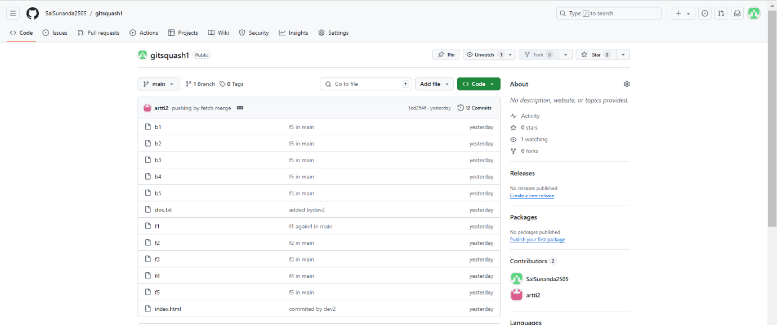 89d6c31..1ed2546 main -> main